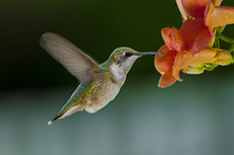
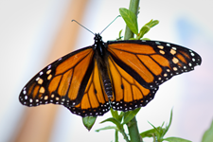
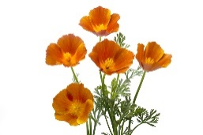
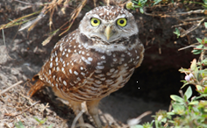

City of Riverside
Outdoor
Adventure Journal

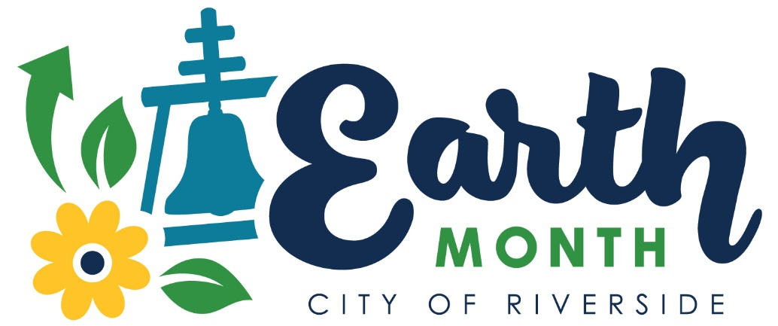

Welcome to Earth Month in beautiful Riverside, California!
With this outdoor adventure journal, we hope you and your family can enjoy the benefits of our city’s outdoor spaces, learn things about local environment and ecosystems, engage in environmentally friendly habits and take actions to help create an even better Riverside.
Each week a new chapter will be posted so don’t forget to check back for new adventures and activities.
Print pages from this book to use or go green and use them as an online tool. Either way, grab your sunscreen, put on those sunglasses, make sure to follow all safety guidelines, and let’s get outside and enjoy our city!

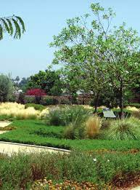
Outdoor Adventures
Did you know Riverside has 48 developed parks (Parks with irrigation) and 17 undeveloped parks (parks like Sycamore Canyon with no irrigation)? Some of our parks have more natural settings like Mount Rubidoux, while others have organized gardens and play areas like Hunt or Shamel Parks. Some of our parks have more natural settings like Mount Rubidoux, while others have organized gardens and play areas like Hunt or Shamel Parks. Riverside also has about 277 sunny days in the year so, no matter which park you choose, if the sun is shining choose one of our beautiful parks to start your Earth Month Adventure.
Track your adventure below.
- Date of my visit Kathleen M. Gonzales Waterwise Garden

- Name of the park I will visit today is

- Things I may need (sunglasses, hat, etc.)

- Write or draw something you see that would provide a home for wildlife.

- Write or draw something you see that would provide water for wildlife.

- Describe or draw a picture of the place you visited.

Energy and the Sun
Energy is the ability to do work. Different kinds of work require different kinds of energy. Since the source of energy is light and heat from the sun, we cannot make or destroy energy. But we can transform the sun’s energy to other kinds of energy to do different kinds of work.
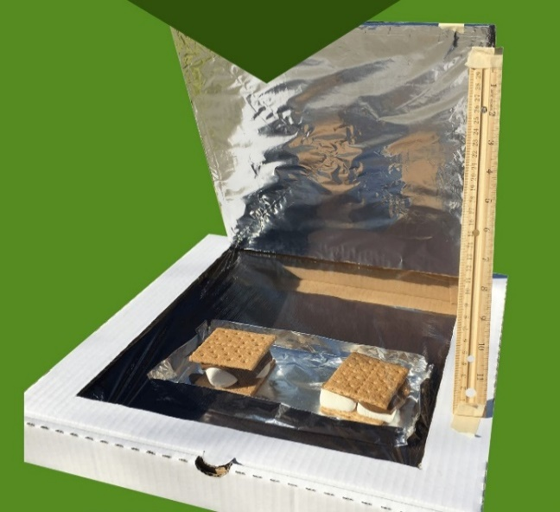
As early as the 1200’s, the sun’s energy was used to dry fruits. In the 1600’s a German scientist was known to have used solar energy to boil water in clay pots, using lenses to direct the sun’s rays.
Keep a look out for Parks & Rec’s wellness vehicle in your area! They will be distributing materials to make Pizza box Solar Ovens and conservation kits for your home! They will be making their round on April 6th at Taft Park from 2-4pm and Bonaminio Park on April 8th from 2-4pm! You don’t want to miss this fun family activity! Make sure to visit www.riversideca.gov/EarthMonth to get directions and view solar oven recipes!

Don’t forget to photograph your project and tag us at Facebook – Riverside Public Utilities, Instagram & Twitter - @RPUNews.
A Pizza Box Solar Oven Snack to Try
Ingredients
1 English muffin, split in half
4 TB pizza sauce
¼ - ½ cup mozzarella cheese, grated
4 -6 pepperoni slices
Instructions
Split the English muffin in halves, and place both in the pie pan.
Spread the pizza sauce on the muffin.
Sprinkle the cheese on top of the sauce.
Place the pepperoni on top of the cheese.
Place the pie pan into the cooking bag and twist tie shut
Place the pan up next to the reflector.
Heat until the cheese is melted and the sauce and pepperoni are hot.
Forms of Energy Scavenger Hunt
Join us on the Earth Month web site for Earth Month Story Time. Read along with the book Energy: Physical Science for Kids. Then grab a parent, sibling or any other friend and head outside or visit one of our beautiful parks. See if you can find examples of these different forms of energy in the world around you. Write or draw what you observed. Which of these energy forms do you think you use most?

Mechanical Energy | Heat Energy | Electric Energy
Chemical Energy | Sound Energy | Motion Energy

More Trees Please
Trees are great for so many reasons, but did you know planting a shade tree could drastically reduce how much energy is used on heating and cooling a home?
If your family gets their utility bill from Riverside Public Utilities, you can use the back of the March 2021 bill to get a free 5-gallon shade tree to plant in your yard.
For now, go to the Earth Month Story Time on the Earth Month web page and read along with the story, We Planted a Tree by Diane Muldrow.
You can also watch the video tips for how to plant a tree.
Then head outside and enjoy your tree or any tree you admire!
Adopt a tree:
Whether it’s a tree in the park, a tree in the yard or your new free tree, choose a tree you can “adopt”. Pick a day in each season to observe and record the following:
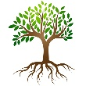
- Using a flexible tape measure, find a point on the trunk of your tree, two feet from the ground.
- At that two-foot point, measure the distance around your tree. Record the date and the measurement. Your first measurement will be labeled spring, followed by measurements in summer, fall and winter for the first year. In the second year you can compare your measurements to see how your tree has changed.
- After measuring your tree each season, look at the branches of your tree. Note if there are leaves, any kinds of fruit, berries, buds, or flowers on them.
- Use the next page to record your data.

Adopt a Tree Data Collection Sheet

Tree Location: ___________________________________
Date of my observations: __________________________
Measurement around my tree, at the two-foot level from the ground: __________________
Observations of my tree’s leaves and branches: _____________
_____________________________________________________
_____________________________________________________
Observations of my tree’s trunk: __________________________
_____________________________________________________
_____________________________________________________
Does your tree appear to be healthy? YES NO
Is there wildlife living in, on, or around your tree? YES NO
Draw a picture of the tree you adopted.

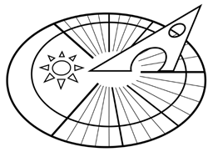
Make a Sun Clock

The sun dial is the oldest known method people have used to track the time. You probably already know, as the sun moves across the sky, objects can cast a shadow on the ground.
Ancient Egyptians used only a stick in the ground to track time, as the sun cast shadows on the stick.
Head outside to make a sun clock of your own by following the instructions on the Earth Month website here: www.RiversideCA.gov/EarthMonth.

