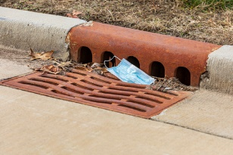
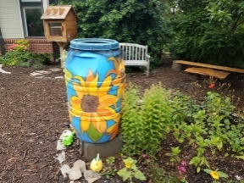
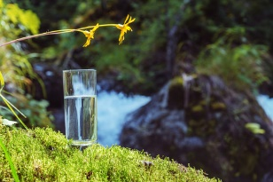
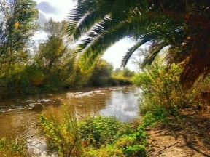

City of Riverside
Outdoor Adventure Journal
Chapter Three

Chapter Three of the Earth Month Outdoor Adventure Journal is all about water, because life can’t exist without it. In Riverside’s hot, dry climate we get an average of 11.3 inches of rain each year. This is not a lot, especially since nearly 350,000 people need to be supplied with enough water to drink, clean, and even play in. Learning where our drinking water comes from, and ways to conserve and protect our water supply is important for every California resident.

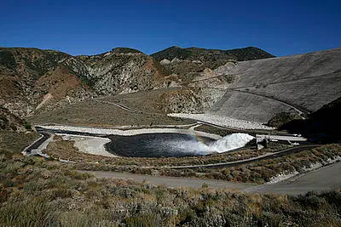
Seven Oaks Dam in Highland California releasing water which will go to settling ponds to recharge Riverside water wells

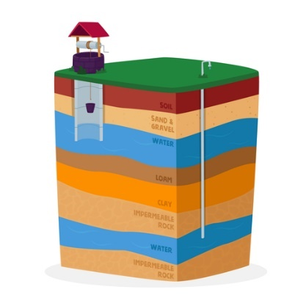
Aquifers
The city of Riverside gets 100% of its drinking water from underground aquifers. When water drips into the ground it is called percolation. It will percolate deep into soils until it reaches bedrock or clay and gathers there underground. That is an aquifer.
Build an Edible Aquifer
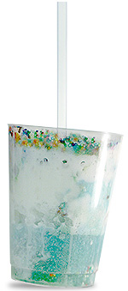
A fun (and tasty) way to understand aquifers and ground water is to build your own edible aquifer.
- Fill a clear cup 1/3 full with crushed ice (represents all of the sand, gravel, and rocks in the aquifer.)
- Add enough soda to just cover the crushed ice. This is our groundwater. See how the “water” fills in the spaces around the “gravel, sand, and rock.”
- Next is the confining layer, which is usually clay or dense rock. The water is confined below this layer. For the confining spread a layer of ice cream over the ice chips and soda.
- Then add more crushed ice on top of the “confining layer.”
- Add a layer of colored sprinkles to represent soils. This layer should be sprinkled over the top to create the porous top layer.
- Food coloring will represent contamination or pollution. In a separate container put food coloring in a small amount of soda. Watch what happens when we pour it on the land. Chemicals like garden fertilizers, oil from vehicles and many other things can pollute ground water.
- Using your straw, drill a well into the center of your aquifer.
- Slowly pump the well by sucking on the straw. Notice the water table go down. The contaminants can get sucked into the well area and end up in the groundwater by leaking through the confining layer.
- You can “recharge” your aquifer by adding more soda. In real life recharge can take many years. Now it’s time to eat your aquifer!

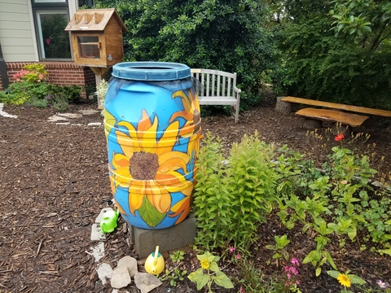
Harvest the Rain
As we use wells to pump ground water from aquifers, it is important to recharge the aquifer or put water back in, so we don’t empty the well completely. But since it can take years for rainwater to percolate back into the aquifer, we must measure the water regularly to make sure we aren’t taking out too much. Check out the video about the Seven Oaks Dam to see how we help speed up the recharge process to keep our wells at appropriate water levels.
When we do get rain, think about ways you can collect that rainwater and save it for use in the garden on hot dry days. This helps Riverside use less water from the aquifers and safes that water for drinking.
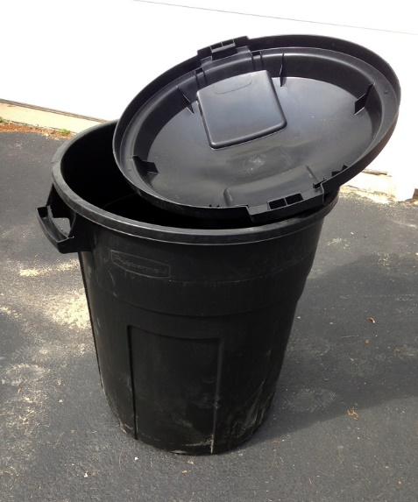
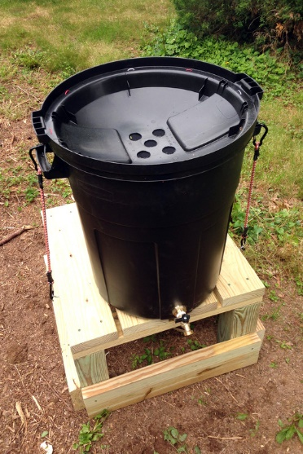
Below is an inexpensive design for a rain barrel made from a rubber garbage can. While this design is simple, you will need help from an adult to put the drainage holes in the lid. If you don’t want to bother with a faucet at the bottom you can always just scoop water from the top into a watering can. Just be sure to attach mosquito screens over the hole so water can get in, but insects stay OUT!
Photos from Just Measuring up
Storm Water Runoff
Everyone on the planet lives in a watershed area. A watershed is the central location in an area, that storm water drains into. In Riverside we are in the Santa Ana River Watershed Area.
The Santa Ana River is home to many plant and animal species necessary for a healthy eco system in our area. The Santa Ana River is also a key component of ground water recharge of nearby cities. Unfortunately, as storm water runs off hard surfaces, it can carry large amounts of pollution. Some pollution like trash we can see, and some, like chemicals from motor oil left on roads, we can’t see. But everyone can do something to help keep the Santa Ana River and its plants and animals free of pollution.
Adopt a Drain
You and your family can adopt a storm drain in the City of Riverside to help keep water in our Santa Ana River free of pollution. All you need to do is go to adoptadrainriverside.com. Look at the map and locate a drain you are interested in adopting. Sign up to adopt the drain and you can get free resources to help you keep your drain clean. Check out this video with more information on how you can help.
https://www.youtube.com/watch?v=A44jHXLZp9A&t=14s
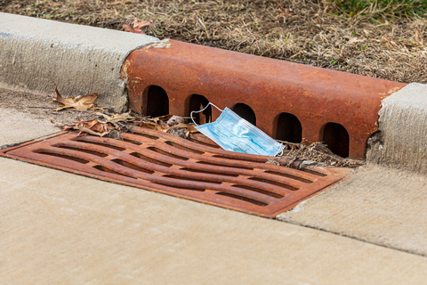
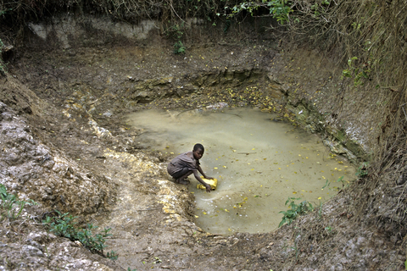
Thinking Globally

Though we live in a part of the world where we don’t have a lot of water, our water is clean and easy to access. For many around the world that is not the case.
Here is a challenge you can do. Find a large bucket or container that you can take outside and fill with water. Then pick up that container and start walking. In many parts of the world, it is the children’s job to collect water. In fact, so much of their time is spent on that chore it is often impossible for them to attend school.
Walking 5 miles is approximately 10,000 steps. See how many steps you can take while carrying your bucket of water. How long would it take you to carry your water 5 miles? Because walking 5 miles from your home by yourself is not a safe idea, keep your steps near your home and family. For many children carrying water, they face many dangers of being far from home.
If you have listened to this week’s Earth Month read aloud stories like, Did a Dinosaur Drink this Water, or The Snowflake, you know every person, plant, and animal on Earth shares the same drinking water. That’s just one more reason to take care of the water we have. How might you help people in other places get access to clean, safe drinking water?
You can also check out this video, Ryan’s Well about a young boy in Canada who did help children he had never met, to get clean water.
https://www.ryanswell.ca/

